BEGINNER’S TOOLKIT

BUILDING MOVIE RATING API WITH SPRING BOOT

1️⃣ Project Overview

Objective:

The objective of this project is to build a simple Movie Rating API that allows users to create, view, update, and delete movies along with their ratings.
This project helps beginners understand how backend APIs work, how data is sent and received over HTTP, and how Spring Boot simplifies backend development.

The main technologies used in this project are:

Java – Programming language

Spring Boot – Backend framework

Spring Web – For building RESTful APIs

Maven – Dependency and project management

Swagger UI – For testing API endpoints

Git & GitHub – Version control and code hosting

Java is widely used in enterprise and backend development, making it a valuable skill for software engineers.

Spring Boot:

Reduces boilerplate code

Handles server configuration automatically

Makes it easy to build REST APIs quickly

Spring Web provides built-in support for HTTP methods like GET, POST, PUT, and DELETE.

Maven simplifies dependency management and project structure.

GitHub allows easy collaboration, version tracking, and project sharing.

These tools are beginner-friendly and commonly used in real-world backend systems.

Examples of Real-World Use of These Tools

Java

Widely used in enterprise systems such as banking and payment platforms

Commonly powers backend services for large-scale applications

Known for stability, performance, and strong community support

Spring Boot

Used to build RESTful APIs quickly with minimal configuration

Common in enterprise backends and microservices architectures

Simplifies application setup using auto-configuration and annotations

Maven

Manages project dependencies and build lifecycle

Used in real-world teams to ensure consistent builds across environments

Helps avoid dependency conflicts in large projects

Git & GitHub

Used for version control and collaboration

Enables tracking of code changes, branching, and merging

Commonly used in professional and open-source software development

Swagger UI

Used to document and test REST APIs directly in the browser

Allows developers to send GET, POST, PUT, and DELETE requests without extra tools

Common in real-world backend systems for API exploration and validation

The API uses in-memory storage, so no database setup is required. Swagger UI is fully integrated for testing endpoints without external tools.

2️⃣ Technology Stack
Layer | Technology
Programming Language | Java
Framework | Spring Boot
Build Tool | Maven
API Documentation | Swagger UI
Version Control | Git & GitHub

3️⃣ System Requirements
Requirement | Minimum
Operating System | Windows, MacOS, or Linux
Java | JDK 17 or higher
Maven | 3.x or higher
Browser | Any modern browser (for Swagger UI)
Optional Tools | IDE (Eclipse, IntelliJ, VS Code), Postman

4️⃣ Prerequisites
- Java JDK 17+ → Run the Spring Boot API
- Maven → Build project & manage dependencies
- Git → Version control
- IDE (Optional): Eclipse, IntelliJ, VS Code → Edit code easily
- Browser → Access Swagger UI
- Postman (Optional) → Test APIs outside Swagger

5️⃣ Clone/COPY/DOWNLOAD the Project
- Open terminal
- Run:
git clone https://github.com/purity-stack/movie-api.git
cd movie-api

6️⃣ Project Structure
- docs/ → Guides and troubleshooting (BEGINNER_TOOLKIT.md, SWAGGER_GUIDE.md, TROUBLESHOOTING.md)
- src/main/java → Controllers, models, services
- src/main/resources → Configuration files (application.properties)
- .gitignore → Ignore unnecessary files
- pom.xml → Maven dependencies
- README.md → Project description

7️⃣ Build & Run the Project
- Navigate to project folder:
cd "C:\path\to\movie-api"
- Build project:
maven clean install
- Run the API:
maven spring-boot:run
OR if using jar:
java -jar target\movie-rating-api-0.0.1-SNAPSHOT.jar
- You should see:
Started MovieRatingApiApplication in X seconds

8️⃣ Access Swagger UI
Open your browser:
http://localhost:8080/swagger-ui/index.html
- Test endpoints directly:
  - GET /movies → Fetch all movies
  - POST /movies → Add a movie
Example JSON for POST:
{
"title": "Inception",
"rating": 9
}
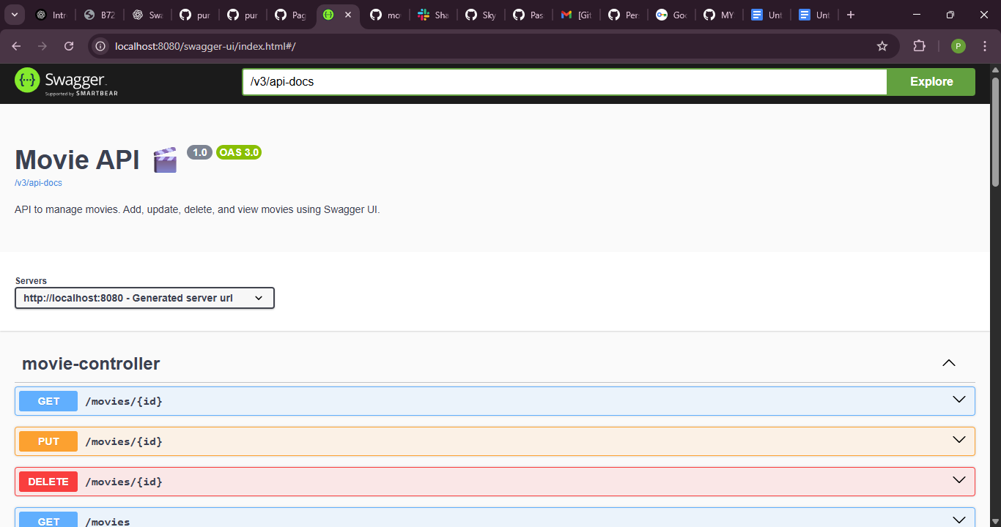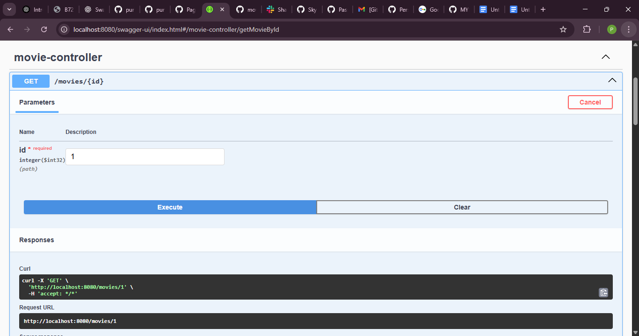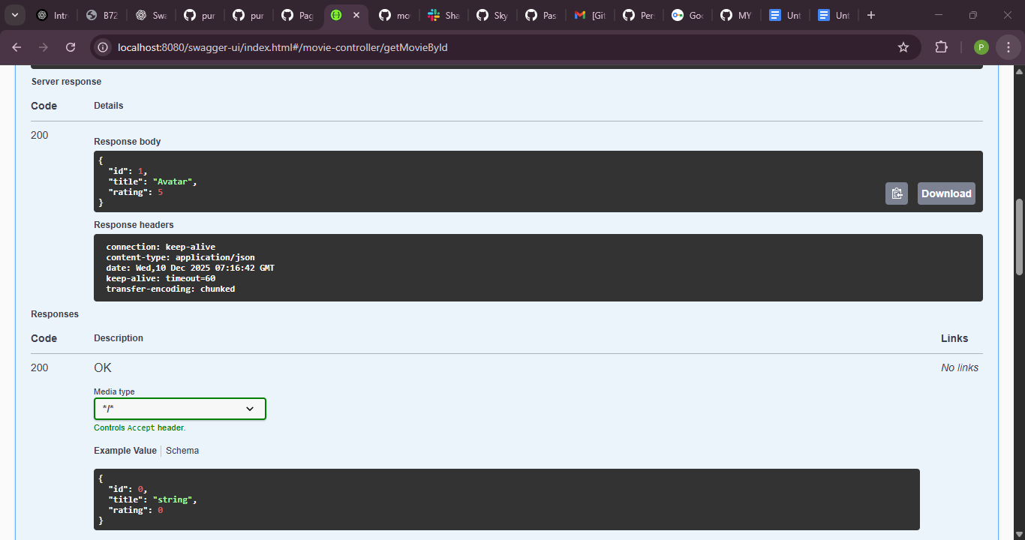
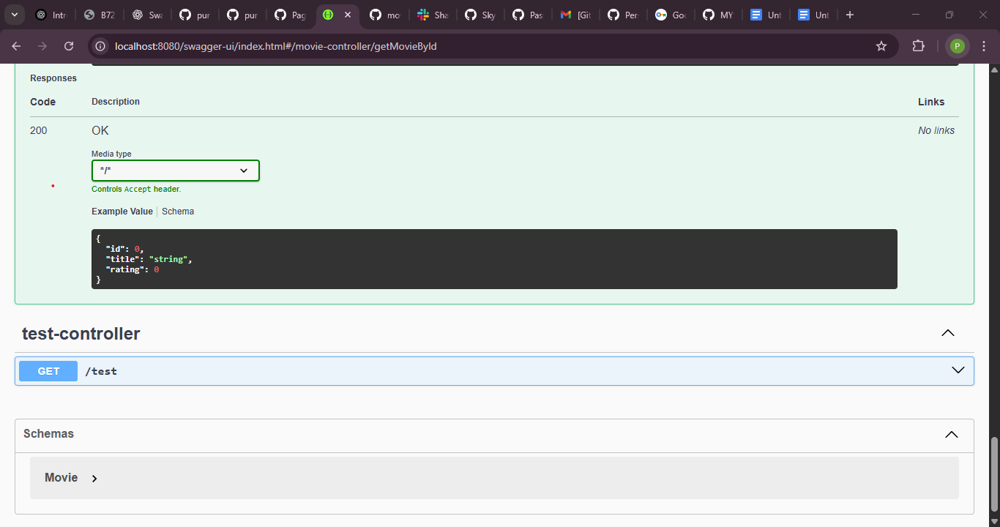

9️⃣ Testing via Postman (Optional)
- GET all movies: GET http://localhost:8080/movies
- POST a movie: POST http://localhost:8080/movies
Body → raw → JSON:
{
"title": "Avatar",
"rating": 5
}

10️⃣ Common Tasks
Task | Endpoint
Add new movie | POST /movies
Get all movies | GET /movies
Get movie by ID | GET /movies/{id}
Update movie | PUT /movies/{id}
Delete movie | DELETE /movies/{id}

11️⃣ Common Issues, Causes, and Fixes
Issue | Cause | Fix
Maven not recognized | JAVA_HOME not set or Maven not installed | Set JAVA_HOME to JDK path, install Maven, add to PATH
Swagger UI not loading | Server not running or wrong port | Check mvn spring-boot:run, confirm port (default 8080)
Port 8080 already in use | Another app running | Stop the other app or change server.port in application.properties
Git push rejected | Remote has commits you don’t have | git pull origin main --allow-unrelated-histories then push again
Merge conflicts | Local and remote files differ | Open conflicting files, resolve markers <<<<<<< >>>>>>>, commit, then push
JSON POST fails | Wrong format or missing fields | Check Swagger example, ensure title & rating are included, no id
API returns 404 | Wrong endpoint or typo | Double-check Swagger path /movies or /movies/{id}
“Permission denied” on Git push | Not authenticated with GitHub | Use browser authentication or Personal Access Token (PAT)
LF/CRLF warnings | Windows line endings | Safe to ignore, or configure git config core.autocrlf true

12️⃣ Git Commands for Beginners
- git status → See changes
- git add . → Stage files
- git commit -m "message" → Commit changes
- git push origin main → Push to GitHub
- git pull origin main → Pull updates from GitHub

13️⃣ C++ → Java Comparison
As someone transitioning from C++ to Java, it’s important to understand key differences:
Feature | C++ | Java
Paradigm | Multi-paradigm (procedural, object-oriented, generic, functional) | Primarily object-oriented (with some functional features since Java 8)
Type System | Statically typed, supports both value and reference types | Statically typed, everything is an object (except primitives)
Memory Management | Manual (using new/delete) or smart pointers (unique_ptr, shared_ptr) | Automatic garbage collection (GC)
Performance | Very high – close to hardware, no GC overhead | High, but generally slower than C++ due to JVM and GC
Compilation | Compiled directly to native machine code | Compiled to bytecode (.class), then JIT-compiled to native at runtime
Platform Independence | Platform-dependent (must recompile for each OS/architecture) | Platform-independent ("write once, run anywhere") via JVM
Execution Environment | Runs natively on the OS | Runs on Java Virtual Machine (JVM)
Pointer Support | Full pointer support (including pointer arithmetic) | No explicit pointers (references only, no arithmetic)
Multiple Inheritance | Supported (for classes, with virtual inheritance) | Not supported for classes (only interfaces, multiple interface inheritance allowed)
Operator Overloading | Fully supported | Not supported (except + for string concatenation)
Standard Library | STL (Standard Template Library) – powerful templates | Rich Java Standard Library (collections, concurrency, I/O, etc.)
Error Handling | Exceptions + manual error codes (return values) | Checked and unchecked exceptions
Threading | Platform-dependent (POSIX threads, Windows threads, etc.) | Built-in threading support with java.util.concurrent
Use Cases | System programming, game engines, high-performance apps, embedded systems | Enterprise applications, web backends (Spring), Android apps, cross-platform tools
Learning Curve | Steeper – manual memory, complex features | Gentler – safer defaults, garbage collection
Safety | Lower – possible memory leaks, buffer overflows | Higher – GC, bounds checking, no pointer arithmetic
Popularity (2025) | Strong in performance-critical domains (games, finance, OS) | Dominant in enterprise, Android, and web services
Tip: Coming from C++, Java provides safer defaults (automatic memory management, no pointers) and platform independence, making it ideal for web and enterprise development.

14️⃣ References
- Spring Boot Guide: https://spring.io/guides/gs/spring-boot/
- Swagger UI Docs: https://swagger.io/tools/swagger-ui/
- Postman Tutorials: https://learning.postman.com/docs/getting-started/introduction/
- Java 17 Documentation: https://docs.oracle.com/en/java/javase/17

